2021 | Vietnam: Destination for your success business




2nd Edition

.


INDEX
- Why Vietnam is the detisnation for your success?
- Potentials & Opportunities
- Legal Framework for Business
- Check list for Establishment in Vietnam



WHY VIETNAM ?



COUNTRY OVERVIEW - 1

  - Population: 97.58 million
(2020)
  - Labor Force: 53.4 million
(2020)
  - Unemployment Rate: 2.26%
(2020)
  - Vietnam income per capita: estimated USD 3,500 (2020)
- Global Competitiveness Index 2019 (latest) rank: 67/140 (61.54/100)

- GDP Growth:
  - 2.91% (2020)
  - 7.02% (2019)
  - 7.08% (2018)
  - 6.81% (2017)
  - 6.21% (2016)
- Industrial Growth in 2020: 3.36%
- GDP by sector (2020):
  - Agriculture, Forestry and Fishery: 14.85%
  - Industry and construction:
33.72%
  - Services: 41.63%



COUNTRY OVERVIEW- 2

- Total direct FDI:
  - USD 28.50B in 2020 (decrease 25% as compared to 2019)
  - USD 38.02B in 2019 (increase 7.2% as compared to 2018)
- Export :
  - USD 281.5B (2020, increase 6.5%)
  - USD 264.19B (2019)
  - USD 244B (2018)

- Public Debt/GDP:
  - 55.8% (2020)
  - 56.1% (2019)
  - 61.1% (2018)
  - 61.3% (2017)
  - 63.7% (2016)
- Inflation:
  - 2.31% (2020)
  - 2.01% (2019)
  - 3.54% (2018)
  - 2.98% (2017)
  - 4.74% (2016)
- Import :
  - USD 262.4B (2020, increase 3.6%)
  - USD 253B (2019)
  - USD 238B (2018)
IMPORT-EXPORT
(2020 compared to 2019)
Import | Export
↑3.6% | ↑6.5%

IMPORT-EXPORT & INVESTMENT
- Trade surplus: 2020 is the fifth year in a row Vietnam has trade surplus, with the highest value of surplus: USD 19.1B (2019: USD 10.9B; 2018: USD 6.5B; 2017: USD 1.9B; and 2016: USD 1.6B).
- Trade surplus of Foreign-invested enterprises in 2020 is USD 34.5B:
- Export USD 203.3B, up 9.7%;
- Import USD 168.8B, up 13.3%.
- Investment by sectors 2020 (19 sectors): Manufacturing and Processing USD 13.6B (47.7% of the registered capital) Power production and distribution USD 5.1B (18% of the registered capital), following by Real Estate Trading and Retail sectors, etc.
- Investment by countries until end of 2020: Among 139 countries and territories investing in Vietnam, EU has 2154 projects with total capital registered of 22.3 Billion USD, rank 6th.

IMPORT/EXPORT 2020
    - Export turnover reached USD 2810.5B (6.5% increase vs 2019)
    - Import turnover reached USD 262.4B (3.6% increase vs 2019)
    - Vietnam’s 2020 trade surplus hits 05 years record of $19.1B after $1.6B in 2016; $1.9B in 2017, $6.8B in 2018 and $9.9B in 2019
    - The US retained its position as the largest export market of Vietnam with a turnover of $76.4 in 2020, marking a yearly hike of 24.5%. It was followed by China ($48.5B), the EU ($34.8B), ASEAN ($23.1B), Japan ($19.2B) and Korea ($18.7B)
    - China continued to be the largest import market of Vietnam with total turnover of $83.9B, signifying an increase of 11.2%, followed by Korea ($46.3B), ASEAN ($ 30B), Japan ($ 20.5B), the EU ($14.5B) and the US ($ 13.7B)

FDI IN FIGURES 2020
- 2020 Vietnam attracted total added capital: USD 28.5B
  - 2,523 new projects with new registered FDI apprx. USD 14.6B = 87.5% compared to 2019
  - 1,381 times of project capital variation, with additional capital of USD 6.4B, ↑10.6% compared to 2019
  - 6,141 capital calls with additional funding equal to USD 7.5B,  51.7% compared to 2019
- Key Sectors of FDI (2020):
  - Manufacturing and processing industry: USD 13.6B = 47.7% of total added capital
  - Power production and distribution: USD 5.1B = 17.9% of total added capital
  - Real estate: USD 4.2B = 14.7% of total added capital
  - Retail and wholesale: USD 1.6B = 5.6% of total added capital



- Top countries investing in Vietnam (2020):
FDI IN FIGURES (2020) - 2
  - Singapore: USD 9.00B (31.5%)
2. Korea: USD 3.93B (13.8%)
3. China: USD 2.46B (8.6%)
4. Japan; 5. Taiwan; 6. Hongkong

Leading provinces of FDI capital (2020):
1. HCMC: USD 4.36B (15.3%)
2. Bac Lieu: USD 4.00B (14.0%)
3. Ha Noi: USD 3.60B (12.6%)
4. Ba Ria – Vung Tau; 5. Binh Duong

- According to the US News and World Report of 2020:
#8 in Best Countries to Invest In (remaining from 2019), based on opinions of more than 6000 business decisions makers on eight different categories:
  - Corruption;
  - Dynamism;
  - Economic stability;
  - Entrepreneurship;
  - Favorable tax environment;
  - Innovation;
  - Skilled labour force; and
  - Technological expertise
Besides, Vietnam also obtained #12 in Best Countries to Start a Business
and #19 in Open for Business Ranking

ECONOMIC PERFORMANCE
- As International Monetary Fund (IMF):
“Despite rising trade tensions and volatility in emerging economies throughout 2018, Vietnam’s economy saw broad-based growth and low inflation. Government spending and debt remained in check and bank capital rules were strengthened. Current economic risks relate to geopolitics, trade policy uncertainty, and domestic reform implementation. Looking ahead to the longer term, Vietnam will face risks related to aging, climate change, and digitalization.”
- As World Bank’s Doing Business 2020: Vietnam ranked 70th (score ↑1.2). Besides, Vietnam has been highlighted in some indexes: Dealing with construction permits (25th, score ↑0.3); getting electricity (27th, score ↑0.3), paying tax (109th, score ↑6.1); getting credit (25th, ↑5 levels)

- Forecasted GDP growth 2021: IMF 6.5%, World Bank 6.7%, HSBC 7.6%, Standard Chartered Bank 7.8%,

FASTEST GROWING ECONOMY
- PricewaterhouseCoopers (PWC) in The Long View: How will the global economic order change by 2050? states as follows:

  - “Vietnam … to be … the world’s fastest growing economies [up until
2050].”

- “Vietnam … could achieve annual average growth of around 5% over the next 34 years.”

  - Vietnam is expected to be world 20th largest economy in 2050 (Korea 18th, Italy 21st, Canada 22nd).

INDEX OF ECONOMIC FREEDOM
INDEX PARAMETER |  | Vietnam’s 2020 Score (out of 100)
Rule of Law | Property Rights | 52.6
Rule of Law | Government Integrity | 33.8
Rule of Law | Judicial Effectiveness | 40.1
Government Size | Government Spending | 75.9
Government Size | Tax Burden | 79.5
Government Size | Fiscal Health | 58.0
Regulatory  Efficiency | Business Freedom | 65.6
Regulatory  Efficiency | Labor Freedom | 62.5
Regulatory  Efficiency | Monetary Freedom | 68.2
Open Market | Trade Freedom | 79.6
Open Market | Investment Freedom | 40.0
Open Market | Financial Freedom | 50.0
*Source: The Heritage Foundation

WEF GLOBAL COMPETITIVENESS REPORT 2019

INDEX PARAMETER | 2018-2019 Ranking | 2017-2018 Ranking
Institutions | 89 | 79
Infrastructure | 77 | 79
Innovation Capability | 76 | 71
Business Dynamism | 89 | 100
Market Size | 26 | 31
Labor Market | 83 | 57
Macroeconomic environment | 64 | 77
*Source: WEF Global Competitiveness Report 2018-2019

IN FOCUS by EUROCHAM:

- Full member of WTO since 2007

- Involvement in the CPTPP & EVFTA
- Fast Growing Economy
- FDI inflows forecast remains strong
- Inflation is at moderate rate
- Exchange rates are stable
- Political stability
- Country risk is at its lowest since the economic crisis.

* Eurocham Whitebook 2020

WHY VIETNAM?

- Privatization of SOEs and liberalization of the banking sector: new entry points for foreign investors.
- Large, skillful and low-cost workforce (highly evaluated by JETRO-
Japan)
- Proximity to China and East Asia markets:
  - → centrally-located to access China and other East Asia &
Australasia markets
  - good manufacturing base for companies to export to the rest of Asia & beyond

- ASEAN coordinator for relations with the India/Japan/Korea in 2015 – 2018/2018 – 2021/2021 - 2024

FTA in which Vietnam has joined cover most continents.

COUPLED WITH WTO ACCESSION IN 2007, IMPLEMENTATION OF FTAs CONTRIBUTE TO BOOSTING
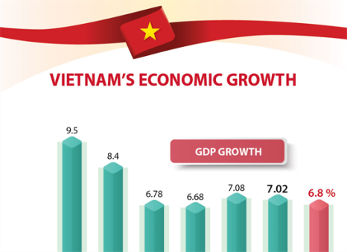 | GDP up  by >300% | 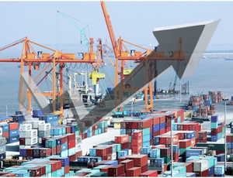 | Export value  up 350%
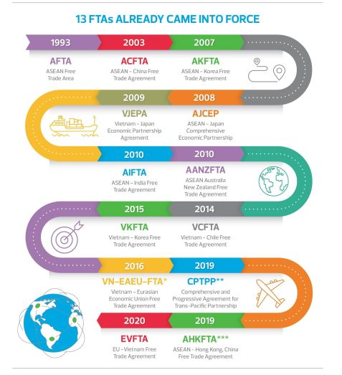
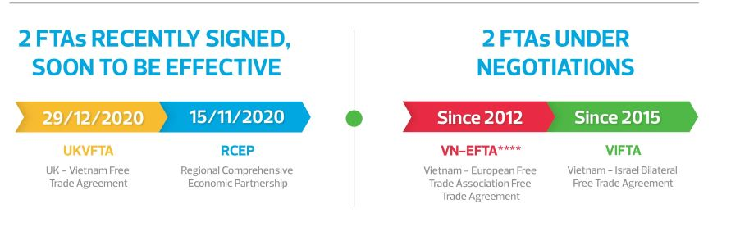

Potentials and Opportunities

COVID-19: NAVIGATING THE BUSINESS
AND LEGAL IMPACTS
- The global and Vietnam economic has been adversely impacted by the spread of the Covid-19 pandemic

- Since the first confirmed COVID-19 case was reported on 23 January 2020, Vietnam government has promptly taken a number of prevention and control measures from an early stage of the epidemic (e.g., travel ban, contact tracing, quarantine and social distancing..) to control the speedy spread of the virus

- Vietnam has been regarded as one of the countries most successfully in containing the Covid-19 pandemic

COVID-19: NAVIGATING THE
BUSINESS AND LEGAL IMPACTS
- The Prime Minister Nguyen Xuan Phuc and relevant authorities have issued a number of regulations to combat the Covid-19 pandemic:
  - Decision No. 447/QD-TTg dated April 1, 2020 officially announced Covid- 19 as a nationwide pandemic;
  - Directive No.15/CT-TTg dated March 27, 2020 on the resolute
implementation of the peak prevention phase of the Covid-19 pandemic;
  - Directive No. 16/CT-TTg dated March 31, 2020 on the implementation of immediate measures for the prevention of Covid-19 pandemic;
  - Directive No. 05/CTTTg dated January 01, 2021 on the implementation of immediate measures for the prevention of Covid-19 pandemic;
  - Official Letter 1064/LDTBXH-QHLDTL dated March 25, 2020 providing guidelines on payment of wages and benefits for employees during work suspension due to Covid-19 pandemic.
Noteworthy points for doing business in Vietnam during the Covid- 19 pandemic:
▪ Workplace and employment
• Review applicable government health alerts
• Take measures to protect health and safety of employees, vendors and
customers who enter your premises or handle your product
• Take measures to protect employees affected by travel bans or quarantined abroad
• Implement a consistent approach to paying employees who are
quarantined or otherwise affected by COVID-19
• Facilitate remote working where possible and maintain regular and transparent communications with employees
• Examine policies, procedures and agreements around paid time off, short- term working, pay reductions and layoffs

Contracts
  - Assessing contractual provisions that have been or may be affected
  - Review contracts with particular regard to force majeure, changed circumstances or material adverse change clauses
  - Consider making transaction via e-contract, e-signature

Data security
  - Issue appropriate privacy notices and obtain consents for planned
monitoring of remote devices
  - Review privacy terms with new vendors or third parties accessing data from your devices
  - Install reliable data security software to better protect your data and information

Supply chains
  - Identify any disruptions impacting business activities
  - Consider to diversify the supply chains
  - Consider the possible customs or export/import restrictions, border closures that may hinder the importation and exportation of raw materials and products

Corporate compliance
  - During the Covid-19 lockdown periods, foreign invested companies (FICs) are still required to submit audited financial statements (AFS) and certain investment, employment and statistic reports (Reports) to authorities via post or email.
  - Be aware of that Covid-19 lockdown, quarantine, travel ban…may lengthen the process of execution and delivery of decision on approval of AFS and Reports

INFORMATION TECHNOLOGY
- Revenue in the ICT sector in 2020 estimated USD 120B, increase
~7.14%
- In the period 2016-2020, average growth rate of ICT sector is 14.7%. In the period 2016-2019, Vietnam ranks 2nd in manufacturing phones and components, 10th in electronics and components products, 13th in digital technology services.
- The strong growth of the telecom and information technology sectors helped upgrade Vietnam’s positions in international rankings (it had a 10th-grade promotion in global competitiveness index – GCI)
- Vietnam is taking strong steps towards the commercialization of 5G, slated for 2020

REAL ESTATE
- Economic situation is stable, real estate demand is growing sustainably with large number of foreign visitors to Vietnam, credit flow to properties are well controlled.
➔ Real estate market in 2020 remains bright as the 3rd ranked sector in attracting FDI.
- In 2020, over USD 4,2B was spent in real estate sector by foreign
investors (equivalent to 17,4% of FDI investment)
- High-end sector has become hotspot market
- Local demand is also continuously rising
- Upward trends on green construction with green technologies
- Expected to benefit from VAMC, increase of ownership cap, credit growth policies, inflation control and low interests

SECURITIES

VN-Index (with increase of 14.86% in 2020)
  - Vietnam's stock market is in the top 5 high growth market in
Southeast Asia
  - The Government continue to push 93 state-owned companies need to be privatized in 2019 – including big conglomerates like Agribank, VINACOMIN, VINACAFE, MOBIPHONE, VNPT .etc
  - Increase of foreign investment cap in local companies & financial service company
  - VND has been stable under SBV’s tools to regulate currency exchange
rates (USD 1/ VND 22,000 – 23,000)
  - Inflation has been less than 3%
  - Stock market reflect the country’s profitable prosperity

RETAIL
  - Wholesale & Retail ↑5.53%
  - In 2020, total retail sales of consumer goods and services reaches USD 219B, which would represent an increase of 2.6% against 2019

Positive Outlook till 2020
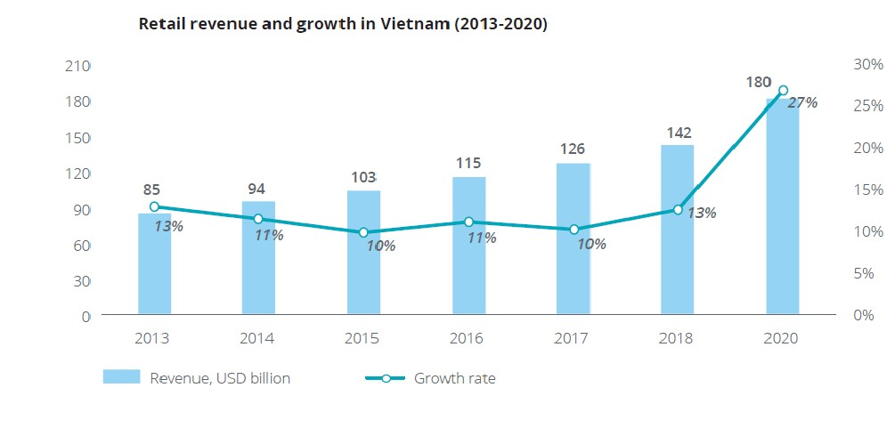
  - Vietnam has a young population with millennials dominant & gen Z are consumers of future
  - Vietnamese consumers are health conscious & taking actions to stay healthy, yet trust issue have to be solved first.
Source: Deloitte Vietnam, Eurocham Vietnam

TRANSPORT, LOGISTICS
AND INFRASTRUCTURE
    - Preferential policies for infrastructure development has been
significantly expanded these past years

    - 10% of GDP has been invested in transport, telecom, energy, water and sanitation in recent years

    - Vietnam gives first priority to infrastructure

    - Budget allocated of USD 34M and project investment needed is USD 15B/year for next 15 years

    - From Jan 2014, WFOE are permitted to provide almost all type of logistics services, including Storage and warehouse services and freight transport agency but excluded container handling services and road transport services.

ENERGY
      - For the development of energy system, VN is facing new challenges:
        - how to ensure an efficient use of domestic energy resources;
        - how to overcome the barriers for energy efficiency;
        - how to utilize the economic potential for renewable energy while securing a stable power supply; and
        - how to successfully contribute to mitigating climate change and air pollution.
      - Government of Vietnam has several key policies for sustainable energy development with four main pillars: EE, RE, energy market and climate change
      - National Power development Plan 2011-2020: energy security,
energy efficiency, power quality and establishing a competitive market

Fitch report:
BANKING

        - Prolonged and rapid credit growth heightens the risk of asset- quality deterioration when banks remain burdened by large bad- debt issues and thin capital buffers.
        - Bank profit: ROA – 0.58%, ROE – 7.87% in 2016 (NFSC report)
        - Credit growth at end-2016 around 18% (2016 target: 18%-20%) and the official credit growth target for 2017 has been capped at 18%

Accelerating the restructure of local banks :
        - Foreign strategic investor can invest in more than 1 local credit institution
        - Limit for foreign strategic investors in credit institution is
increased to 20% instead of 15%. 20% cap may be lifted by the PM to restructure and ensure the weak banks to be safely restructured

Export:
ELECTRONICS

  - The total export earnings from electronic products and parts rose from $35.93B in 2019 to $44.58B in 2020, which was increased of 24,1%;
  - Export was mainly to China ($11.09B), increased 16%, the U.S. ($10.39B) increased up to 71.7%, the EU ($6.51B), Hong Kong ($4.19B), etc.
  - Export revenue mostly belongs to FDI (>90%)

Import:
  - The total import earnings from electronic products and parts rose to $64.0B in 2020, which was increased of 24,6% and made the largest contribution.
  - Import was mainly from China ($18.5B) which was increased of 52%, Korea ($14.1B), Taiwan ($7.7B), etc.

ELECTRONICS

Samsung continued to lead smartphone market
- The company has invested a cumulative USD 17B in the country.
- Samsung is the largest Korean investor in Vietnam
- In 2017, Samsung revenue in Vietnam was USD 58B and Samsung became the biggest company in Vietnam, bigger than PetroVietnam, the state oil company.
- Samsung plants in Thai Nguyen and Bac Ninh are two largest smartphone manufacturing projects of Samsung in the world.
- Samsung employs more than 130,000 employees in Vietnam. Samsung made Vietnam the second-biggest exporter of smartphones in the world, after China.
- In 2019, Samsung accounted for 22% of Vietnam’s total exports (with values of USD 59B).

GARMENT & TEXTILE
      - Vietnam's biggest export market for textile and garment is the US market with $14B (around 47% of all markets in 2020).
      - VITAS (Vietnam Textile & Apparel Association) recognizes that the market share of Vietnam's garment and textile export has reached 20% for the first time in the US market in 2020.
      - Garment & textile export is expected to reach USD 39B in 2021, equivalent to 2019, despite the reduction in global demand.
      - UKVFTA, along with EVFTA, is expected to boost the growth of
garment and textile industry in Vietnam in the UK and EU markets.





LEGAL
FRAMEWORK FOR BUSINESS

ENTRY METHODS

      - The Law on Investment 2020 applies a “negative-list” market
entry restrictions for foreign investors.
Outside of this list, foreign investors are entitled to the same
market entry conditions as applicable to domestic investors.
      - Entry methods:
        - Establishment of a enterprise
        - Acquisition of, and investment in, an existing enterprise
        - Public private partnerships (PPP) contracts
        - Business cooperation contracts (BCC)

ENTRY METHODS (CONT)

Establishment of a enterprise
- Foreign investors can set up a new enterprise in Vietnam, whether as a wholly owned subsidiary or as a joint venture with foreign or Vietnamese partners.
- The investor needs to go through procedures to establish an enterprise to implement the investment project.
- Approval of the investment project is in the form of an Investment Registration Certificate (IRC). Certain types of projects may require an in-
principle approval by the National Assembly, the Prime Minister or the relevant local People’s Committee before the IRC is issued (e.g projects for investment in airports, seaports, petroleum, casinos and golf courses).
- Once the IRC is issued, the investor must then apply for an Enterprise
Registration Certificate (ERC) to establish the new enterprise that will
implement the investment project.

ENTRY METHODS (CONT)

Acquisition of, and investment in, an existing enterprise
- Investors may also choose to invest in Vietnam by acquiring all or part of an existing enterprise
- A foreign investor is required to obtain the approval for M&A transaction (“M&A Approval”) if the acquisition leads to:
  - an increase in foreign ownership in a company engaging in business
lines with market access conditions
  - an increase in foreign ownership in a company from 50% or less to more than 50% of charter capital, or a further increase in foreign ownership if it has been more than 50%.
  - M&A Approval is also required if the acquisition of a company which has a land use right certificate on an island, a coastal or in another area which affects national defence and security.

ENTRY METHODS (CONT)

Public private partnerships (PPP) contracts
- Foreign investors can invest in public sector projects under public private partnership (PPP) arrangements.
- Law on Public –Private Partnerships dated 18 June 2020. The PPP Law establishes the legal framework for all PPP projects and aims to attract more private investment to the development of Vietnam’s infrastructure.
- Permitted sectors: transportation; power plants and power transmission lines; irrigation works, clean water supply, water drainage and waste water treatment, and waste treatment; healthcare, education and training; information technology infrastructure
- PPP investment models: Build – Operate – Transfer (BOT); Build – Transfer – Operate (BTO); Build – Own – Operate (BOO); Operate – Manage (O&M); Build – Transfer – Lease (BTL); Build – Lease – Transfer (BLT); and mixed contracts combining (a) BOT, BTO, BOO or O&M and (b) BTL or BLT.

ENTRY METHODS (CONT)

Business Cooperation Contracts (BCC)
- A BCC contract is a written contract between investors, agreeing to cooperate to undertake certain business activities and to share the profits or products arising from such activities.
- No separate legal entity or company is established and there is no limitation on liability for participants.
- An IRC must be obtained for BCCs involving foreign investors.
- BCCs have been used mainly in the petroleum and telecommunication sectors.

INVESTMENT LIMITATIONS

Prohibited business lines:
  - Trade in the narcotic substances
  - Trade in the chemicals and minerals
  - Trade in specimens of wild flora and fauna, specimens of rare
and/or endangered species of wild fauna and flora
  - Prostitution
  - Human trafficking; trade in human tissues and body parts
  - Business pertaining to human cloning
  - Trade in firecrackers
  - Debt collection
- Conditional business lines: 227 business lines

INVESTMENT LIMITATIONS (CONT)

Foreign ownership cap
Limitations are also imposed on foreign investors in certain sectors in
terms of percentage of ownership. For instance:

  - The aggregate foreign investment in Vietnamese commercial banks
is limited to 30 per cent; and

  - ‘Equitisation plans’ for State-owned enterprises undergoing the process of equitisation (ie privatisation) may specify foreign ownership limits

INVESTMENT INCENTIVES

Business lines subjects to investment incentives:
  - High technologies and Bio-technologies
  - Manufacturing of new materials, new energy, clean energy, renewable
energy
•
Manufacturing of IT products, software products Collection, treatment, recycling or re-use of waste Agriculture, forestry and Aquaculture Infrastructure
•
•
•
•
Collection, treatment, recycling or re-use of waste Education
•
•
Medical

INVESTMENT INCENTIVES (CONT)

Forms of investment incentives:
  - Corporate income tax incentives: application of a lower rate of corporate income tax; Corporate income tax exemption
  - Import tax incentives: exemption from import tax on goods imported to form fixed assets; raw materials, supplies and components for manufacturing purposes in accordance with regulations of law on import and export tax
  - Land levy and rent incentives: exemption from and reduction of land levy and land rents
  - Deductible expenses: depreciation and increase in deductible expenses
upon calculation of taxable income

NEW FOCUS IN FDI PROMOTION
Efficiency & productivity optimization is keys for further development
→ Cut down “dirty, low efficiency & low added value” industries in calling for FDI. Focusing onto
  - Infrastructure
  - High-quality personnel
  - Supporting industries
  - Agriculture
  - High-technologies

INVESTMENT DISPUTE SETTLEMENT

Investor-State Dispute Settlement (ISDS)
- Vietnam has signed Bilateral Investment Treaties (BITs) with 64 countries and regions, entered in 11 Free Trade Agreements (FTAs) e.g. CPTPPP, EVFTA…etc, and is in the process of negotiating other 5 FTAs. Most of these agreements contain ISDS provisions with the purpose of protecting investors whilst investing in Vietnam.
- Under Law on Investment 2020, any dispute between investors and Vietnam government related to investment activities can be settled through:

  - Vietnam’s court
  - Vietnam’s arbitration
  - Foreign arbitration
  - International arbitration
  - An arbitral tribunal established by the parties

COMPANY FORMATION

Company forms
- There are three main private company forms for both domestic and foreign-invested enterprises:

  - single member limited liability company (SLLC);
  - multiple member limited liability company (MLLC); and
  - shareholding company, also referred to as a joint stock company (JSC).

- Other less common forms include sole proprietorship and partnership companies.

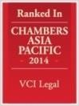
voted “Vietnam Corporate Law Firm of
The Year” by
Copyright ©2013– 2014 VCI Legal All right reserved. This presentation and its contents are copyrighted under applicable Vietnamese and international laws. Contents of this Presentation, in whole or in part, could not be used without the authorization of the author in writing. Any unauthorized use is subject to be penalized under applicable laws and regulations
SLLC | MLLC | JSC
Investors and the organizational structures
Investors: The sole investor may be an organization or an individual.  The organizational structure:  Model 1: President and Director; Model 2: Members’ Council and Director | Investors: Two or more investors, limited by fifty investors who may be organizations or individuals.  The organizational structure:  Members’ Council, President of the Members’ Council, Director or General Director | Investors: Three or more investors (no upper limit) who may be organizations or individuals  The organizational structure:  Model 1: General Meeting Shareholders, Board of Management, Board of Controllers and Director; or Model 2: General Meeting Shareholders, Board of Management and Director
 | Capital mobilization
Cannot issue shares. Subject to conditions, can issue bonds to raise capital, but not convertible bonds. | Subject to conditions, can issue bonds to raise capital, but not convertible bonds. | Must have ordinary shares and may have preference shares, including voting, dividend, redeemable preference shares and other types stipulated in the charter. Subject to conditions, may issue bonds to raise capital, including convertible bond
 | Transfer of capital
Where an investor transfers only part of the charter capital, the SLLC must register for conversion into an MLLC.  The new member must also be registered in the ERC.  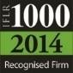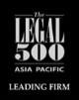 | An investor wishing to transfer all or part of its capital contribution must first offer to sell such share of capital contribution to all other investors proportionally.  Member’s rights and obligations are transferred when the transferee is registered in the members’ registry maintained by the company.  The new member must also be registered in the  ERC. | Shares may be freely transferred (unless they are subject to certain limitations on founding shareholders in the first three years, or otherwise restricted under the charter or law).  Voting preference shares may not be transferred.  The transfer of shares will be completed when the new shareholder is registered in the shareholders’ registry maintained by the company.



  - Enterprise Registration Certificate
- An enterprise needs to obtain an ERC upon its establishment. The enterprise has legal personality from the date of issue of the ERC
(equivalent to a certificate of incorporation in other jurisdictions).
- The establishment of a new foreign invested enterprise additionally requires an IRC before an ERC can be issued.

Charter
- All companies must have a charter, (equivalent of a constitution or
articles of association of a company in other jurisdictions). The charter sets out basic company details and the rules for management of the company
▪

Legal representative
  - The legal representative of a company is the person authorised to
represent, and sign documents on behalf of, the company.
•
A company may have one or multiple legal representatives. In the latter case, the allocation of power and authority between the legal representatives must be specified in the charter.

Tax registration and payment of the business license tax
- The business license certificate number is also the company’s tax number.
- All companies must pay taxes through an online system. Companies
also submit tax declarations and reports through this system. To gain
access to this system, businesses must get an electronic signature.

Company’s seal
- Under the Law on Enterprises 2020, an enterprise have the right to
determine the type, form, number of its seal
•
The management and usage of the enterprise’s seal in accordance with the charter
•
Enterprises do not have to register or notify its seal specimen to authorities before put it into use
•
Enterprises are allowed to use both physical seals and digital signatures when executing company documentation. The digital signatures will be given the same legal weight with the traditional physical seals.

LAND

- Land owned by the People
- Land use right (LUR) entitles the holder to
exclusively use the land
- LUR Acquisition:
  - Lease from State or permitted lessors
  - As capital contribution from VN party to a JV
- Land Lease duration: 50-70 years
- Mortgage and sub-lease of land Impossible but possible to Mortgage and sub-lease LUR

TAXES

Corporate Income Tax (CIT)
  - Standard rate 20%
  - Tax holiday - CIT exemption up to 4 years from the date of issuance of investment certificate followed by a period of 50% Taxes.
  - 10% and 20% tax rates for investments in encouraged sectors

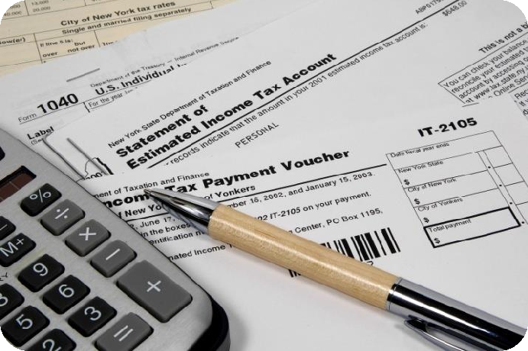

- Import and export duties Investors meeting certain conditions are entitled to incentives on import duties for initial fixed assets

Land rental, land usage fees
  - Applicable to investors with investments in an encouraged sector or region
•
Exemption or reduction from land taxes, land use fees and water surface rentals.
•
Allocation of land with or without land use fees

CAPITAL MARKETS & SECURITIES
- Foreign Invested Enterprise (FIE) may sell shares to either foreign
or local citizen or entities
- FIE sell all its shares to foreigners: Amendment of IC
- FIE sells all its shares to local: IC changes into Enterprise
Registration Certificate (ERC)
- 2 stock exchanges: HSX & HNX

- Proposal to merge into a unique Vietnam Stock Exchange (approved by the Prime Minister’s Decision No. 37/2020/QD-TTg which takes effect on February 20, 2021)
- Securities law 2006:
  - USD 480,000 to be listed
  - Minimum of 100 investors

INTELLECTUAL PROPERTY
  - IPR system is divided into 3 areas:
    - Copyright and related rights- administered by the Copyright Office
of Vietnam
    - Industrial Property Rights: administered by the NOIP
    - Right to plant varieties: administered by the Plant Variety
protection Office
  - Administrative actions: fines, seizure and destruction of counterfeit
goods, business license suspension and re-exportation of infringed imported, etc
  - Civil actions: Preliminary injunctions and compensation for damage
are available through the civil courts
  - Criminal prosecution: government authorities or right owners can
bring prosecutions: fines, imprisonment and even death penalty in
serous, organized or business-related cases.

RECENT FAVORABLE POLICIES FOR FDI-1
  - Foreign ownership in Vietnamese listed companies is limited to 49% instead of 30%.
  - Foreign ownerships in local banks is loosened:
    - Individual investor: 5% cap
    - Organizations: 15% cap
    - Strategic investors: 20% cap
    - Related parties: 20% cap
    - Aggregate foreign ownership applicable to commercial banks: 30%
    - Aggregate foreign ownership applicable to finance and financial
leasing companies: 49%

RECENT FAVORABLE
POLICIES FOR FDI-2
- Equitization of SOE (573 SOEs by 2015, 52 SOEs by 2016, 24 SOEs by 2017, 23 SOEs by 2018 ,11 SOEs by 2019):
  - Foreign investors are eligible to buy a limited amount of share in an SOE
  - Share acquisition are limited to 3 strategic investors
  - Strategic investors must hold their shareholding for a minimum of 5 years
- Establishment of VAMC in July 2013 to resolve VND 50 Trio
(equivalent to USD 2.2B) of bad debt
- Tax allowances:
  - CIT reduction from 25% to 22% from Jan 2014
  - 20% reduction from Jan 2016

without the authorization of the author in writing. Any unauthorized use is

KEY TRADE REGULATIONS

Various regulations:

  - WTO commitments 2007: Market opening and equal treatment between foreign and domestic investors.
  - Bilateral / Multinational Trade Agreements
  - Local regulations for FDI
firms, commercial laws, etc.,
- Representative Office + Local Agents (invoicing & logistics)
- Vietnam encourages the import
of
  - hi-tech products and items that Vietnam does not produce
  - input materials for manufacturing

BUSINESS checklist

CHECKLIST OF DOCUMENTS REQUIRED FOR APPLICATION FOR ESTABLISHMENT OF
A 100% FOREIGN INVESTED ENTERPRISE

CLIENT: ABC CORPORATION (“the Investor”)
THE TO-BE-ESTABLISHED SUBSIDIARY IN VIETNAM (“the Company”)

NB: (A) This Checklist is prepared in accordance with the Vietnam’s prevailing legislation and our verbal discussions with the licensing authorities. Additional documents may be required by the licensing authorities at their discretion during the process of assessment of the application dossiers and we will keep you posted timely.
(B) Each of the documents required below is made into two (02) originals or notarized/legalized copies (one is for submission to the licensing authorities and one is for the Company’s record retention purpose as required by the laws), except specific requirement in the Checklist.
No. | Documents | Prepared by | Languages | Signature/Seal requirements | Notes
STEP 1: APPLICATION FOR INVESTMENT REGISTRATION CERTIFICATE (“IRC”) OF THE INVESTMENT PROJECT
 | Application letter for implementation of the investment project | A to provide the draft | English & Vietnamese | - INITIALED (on each page) and SIGNED (on the last page) by the Legal Representative or duly authorized signatory of the Investor; and  - AFFIXED (on the last page) with the seal/stamp of the Investor.
 | Proposal for the investment project | A to provide the draft | English & Vietnamese | - INITIALED (on each page) and SIGNED (on the last page) by the Legal Representative or duly authorized signatory of the Investor; and  - AFFIXED (on the last page) with the seal/stamp of the Investor.
 | Technical and Economic Explanation of the investment project | A to provide the draft | English & Vietnamese | - INITIALED (on each page) and SIGNED (on the last page) by the Legal Representative or duly authorized signatory of the Investor; and  - AFFIXED (on the last page) with the seal/stamp of the Investor.
 | Documents proving the legal status of the Investor:
 | 4.1. Legalized (*) copy of the Certificate of Incorporation/Certificate of Business Registration/Business Licence of the Investor | Client to provide | Home language (or English) & certified Vietnamese translation |  | 2 legalized copies are required.
 | 4.2. Legalized (*) copy of the Memorandum of Association and Articles of Association of the Investor | Client to provide | Home language (or English) & certified Vietnamese translation |  | 2 legalized copies are required.
 | Documents proving financial capability of the Investor
 | 5.1. Report on financial capability of the Investor | A to provide the draft | English & Vietnamese | - INITIALED (on each page) and SIGNED (on the last page) by the Legal Representative or duly authorized signatory of the Investor; and  - AFFIXED (on the last page) with the seal/stamp of the Investor.
 | 5.2. Copy of Audited Financial Statements of the Investor for the latest two (02) years; OR Original Confirmation letter of a bank proving the sound financial capability of the Investor signed and stamped by the bank | Client to provide | Home language (or English) & certified Vietnamese translation |  | Please provide the original audited Financial Statements if available
 | Documents relating to the proposed premises of the Company:  - Original or notarized copy of the Memorandum of Understanding on office leasing or Offer to Lease or Lease Contract;  - Lessor’s documents related to the leased office:  - Notarized copy of ID card and Certificate of Business Registration for Household (for individual) or Certificate of Business Registration (for corporate entity);  - Notarized copy of ownership certificate of house/building;  - Notarized copy of Minutes on construction completion;  - Notarized copy of the lease contract between the landlord and the lessor (in case the lessor and landlord are not the same);  - Notarized copy of Certificate of Business Registration of the landlord (in case the lessor and the landlord are not the same) | Client to provide | Vietnamese |  | If landlord is a corporate entity, this corporate entity must have the office lease business function stated in its Certificate of Business Registration.  These documents need to be notarized by a competent Vietnamese authority.
 | Legalized (*)/notarized copies of Passports of:  - The Legal Representative of the Investor;  - The duly authorized signatory of the Investor (if any). | Client to provide | Home language (or English) & certified Vietnamese translation
 | Power of Attorney to sign documents (in case the signatory of the Investor is other than the Legal Representative of the Investor) | A to provide the draft | English & Vietnamese | - INITIALED (on each page) and SIGNED (on the last page) by the Legal Representative or duly authorized signatory of the Investor; and  - AFFIXED (on the last page) with the seal/stamp of the Investor. | U3 originals are required
 | Authorization Letter for A’s staff to act on behalf of the Investor during the licensing process | A to provide the draft | English & Vietnamese | - INITIALED (on each page) and SIGNED (on the last page) by the Legal Representative or duly authorized signatory of the Investor; and  - AFFIXED (on the last page) with the seal/stamp of the Investor.
STEP 2: APPLICATION FOR ENTERPRISE REGISTRATION CERTIFICATE (“ERC”) OF THE COMPANY
 | Application letter for registration of enterprise | A to provide the draft | English & Vietnamese | - INITIALED (on each page) and SIGNED (on the last page) by the proposed Legal Representative of the Company.
 | Charter of the Company | A to provide the draft | English & Vietnamese | - INITIALED (on each page) and SIGNED (on the last page) by the Legal Representative or duly authorized signatory of the Investor and the Legal Representative of the Company; and  - AFFIXED (on the last page) with the seal/stamp of the Investor.
 | Decisions of Investor:
 | 3.1 Authorization letter of the Investor to appoint the Authorized Representative(s) in the Company | A to provide the draft | English & Vietnamese | - INITIALED (on each page) and SIGNED (on the last page) by the Legal Representative or duly authorized signatory, and Authorized Representative(s) of the Investor; and  - AFFIXED (on the last page) with the seal/stamp of the Investor.
 | 3.2. Decision of the Investor on appointment of Legal Representative(s) of the Company | A to provide the draft | English & Vietnamese | - INITIALED (on each page) and SIGNED (on the last page) by the Legal Representative or duly authorized signatory of the Investor; and  - AFFIXED (on the last page) with the seal/stamp of the Investor.
 | List of Authorized Representative(s) of the Investor in the Company | A to provide the draft | English & Vietnamese | - SIGNED by the Authorized Representative(s) of the Investor in the Company on the signature box;  - SIGNED by the proposed Legal Representative of the Company.
 | Documents proving the legal status of the Investor: |  |  |  | Provided in Doc. 4 - Step 1
 | 5.1. Legalized (*) copy of the Certificate of Incorporation/Certificate of Business Registration/Business Licence of the Investor; | Client to provide | Home language (or English) & certified Vietnamese translation
 | 5.2. Legalized (*) copy of the Memorandum of Association and Articles of Association of the Investor | Client to provide | Home language (or English) & certified Vietnamese translation
 | Legalized (*)/notarized copies of Passports/Identification Cards of:  - The proposed Legal Representative(s) of the Company; and  - The Authorized Representative(s) of the Investor in the Company. | Client to provide | Home language (or English) & certified Vietnamese translation
 | Notarized copy of the Company’s IRC | A to assist | Vietnamese |  | Upon completion of Step 1
 | Power of Attorney to sign documents (in case the signatory of the Investor is other than the Legal Representative of the Investor) | A to provide the draft | English & Vietnamese |  | Provided in Doc. 8 - Step 1
- 9 | Legalized (*) / Notarized Authorization Letter for A’s staff to act on behalf of the Company during the licensing process | A to provide the draft | English & Vietnamese | - INITIALED (on each page) and SIGNED (on the last page) by the proposed Legal Representative of the Company. | In case the Authorization Letter is notarized in Vietnam, the Notary Public will provide the template to be prepared in 3 notarized copies
STEP 3: POST-LICENSING PROCEDURES
3.1. Registration of the account for foreign invested enterprise/project on the National Portal of Foreign Investment
 | Registration letter for creation of account for foreign invested enterprise, project | A to provide the draft | English & Vietnamese | - SIGNED (on the last page) by the Company’s Legal Representative;  - AFFIXED (on the last page) with the Company’s seal;  - AFFIXED with the cross seal/fan seal so that a piece of the Company’s seal is affixed to each page of the document.
 | Notarized copy of the Company’s IRC | A to assist | Vietnamese
 | Authorization Letter for A’s staff to act on behalf of the Company in the post-licensing process | A to provide the draft | English & Vietnamese | - SIGNED (on the last page) by the Company’s Legal Representative;  - AFFIXED (on the last page) with the Company’s seal;  - AFFIXED with the cross seal/fan seal so that a piece of the Company’s seal is affixed to each page of the document.
3.2. Public Announcement on National Information Portal (within 30 days from the issuance date of ERC)
 | Application for publication of enterprise registration contents | A to provide the draft | Vietnamese | - INITIALED (on each page) and SIGNED (on the last page) by the Legal Representative of the Company.
 | Notarized copy of the Company’s ERC | A to assist | Vietnamese
 | Notarized Authorization letter for A’s staff to act on behalf of the Company during the licensing process | A to provide the draft | English & Vietnamese | - INITIALED (on each page) and SIGNED (on the last page) by the Legal Representative of the Company. | Provided in Doc. 9 – Step 2
3.3. Seal
a. | Carving the Company’s seal
 | Copy of the Company’s ERC | A to assist | Vietnamese
 | Copy of the information page of the passport of the Company’s Legal Representative | A to assist | Home language
 | Copy of the Identity card of the authorized person from A | A to provide | Vietnamese
1Bb. | Notification about the usage of seal
 | Notification on the usage of seal sample | A to provide the draft | English & Vietnamese | - SIGNED (on the last page) by the Legal Representative of the Company;  - AFFIXED (on the last page and on the provided box) with the seal of the Company; and  - AFFIXED with the cross seal/fan seal so that a piece of the Company’s seal is affixed to each page of the application letter.
 | Notarized copy of the Company’s ERC | A to assist | Vietnamese
 | Notarized Authorization letter for A’s staff to act on behalf of the Company during the licensing process | A to provide the draft | English & Vietnamese |  | Provided in Doc. 9 - Step 2

Note:U
- Legalized procedure for documents marked with (*):
- The Ministry of Foreign Affairs signature and seal would then be legalized by the Vietnamese Embassy.
A can assist in liaising with authorized translation firms in Vietnam to have the notarized and legalized documents translated into Vietnamese first (to ensure the accuracy of the translation) before a Notary Public in Vietnam certifies the same. The Company will bear all incurred translation and notarization fees.
- A reserves the right to request the Company to provide additional documents that the relevant authorities may requested, as within their discretion, during the review process.

CHECKLIST OF DOCUMENTS REQUIRED FOR APPLICATION FOR ESTABLISHMENT OF
REPRESENTATIVE OFFCIE IN VIETNAM
1/ ROs are permitted to engage in the following activities:
Conducting market research;
Acting as a liaison office for its parent company;
Promoting the activities of its head office through meetings, and other activities, that leads to business at later stages.
Representatives offices are dependent on their parent company and are not allowed to generate their own profits or enter directly into contracts. They are also not allowed to issue invoices.
2/ What do you need to get a license?
Pre-licensing checklist for setting up a RO:
File an application for setting up a RO with company chop or seal;
Appointment letter of Chief of RO with identification documents and company seal;
Power of attorney in favor of consultant to submit the application dossier;
Certificate of Incorporation for the Company and/or Business Registration Certificate of the Company;
Audited financial report of the company for the latest fiscal year;
Memorandum of Understanding (MoU) of leasing office or leasing contract;
Documents providing legal rights of landlord regarding the right of leasing office.
For steps 1 to 6, the foreign entity would require one notarized and consularized copy of each document and a translated copy in Vietnamese by a Vietnamese competent authority.
A signed leasing contract is also required before registering a RO in Vietnam.
3/ What do you need to do after you get the license?
Post-licensing checklist for setup a RO:
Make a seal for the RO;
License on the establishment of RO
Passport of Chief of RO if foreigner or passport/ID card if Chief is Vietnamese
Register a Tax code for RO;
Declaration to register a tax code
Power of attorney
Certificate of seal registration
Certificate of RO in Vietnam
Open a bank account of RO;
License on the establishment of RO
Certificate of seal registration
Certificate of tax code registration
Letter of authorization appointing the authorized signatories of the bank accounts
Announcement of the establishment of RO of Company.
For steps 8 to 10, notarized and translated documents will be required to complete the process.
4/ How long does it take to set up an RO?
ROs can be set up in between six to eight weeks. We recommend hiring a professional service to deal with the myriad of laws and procedures.
Given the absence of in-country revenue and associated licensing requirements, the setup process for this option does not entail as many bureaucratic procedures as others.
An RO license is valid for five years but can be extended for another five years.
5/ What comes next?
Hiring, tax, and reporting.
There is no cap on the number of local and expatriate employees that a representative office can hire as long as their employment is properly documented.
All expatriate hires including the chief representative are required to have a work permit. ROs can hire staff directly or use the assistance of recruiting agencies.
An RO is not subject to Vietnamese corporate income tax (CIT). However, it is responsible for declaring its employees’ personal income tax (PIT).
In order to determine payable tax, ROs have to undertake a tax audit that checks all revenues and expenses during the tax term to establish grounds for declaring and paying tax.
The RO also has to send reports of its activities of the previous year to the Department of Industry and Trade before January 30 of each year.
Tax risks if RO viewed as Permanent Establishment
As discussed earlier, an RO is only permitted to do market research activities and act as a liaison office for its parent company. It cannot engage in commercial activities or support the parent company with its commercial activities in Vietnam.
A Permanent Establishment (PE) is defined as per local laws as well as the double tax avoidance (DTA) agreement between Vietnam and other countries. Generally, the PE definition under a DTA takes precedence over domestic regulations.
If a foreign business wants to convert the RO into a PE but has been carrying out activities as per local laws, it could activate a licensing risk. Therefore, foreign businesses should ensure that their RO performs activities as per the DTA guidelines. In addition, if the RO performs activities that are outside its scope, it may be subject to additional tax in Vietnam.
To avoid any licensing or tax risks in case the RO is treated as a PE, businesses are advised to refrain from getting their ROs involved in buying and selling activities between two parties or any other activities generating revenue.
Foreign investors looking to establish a presence in Vietnam should use the services of registered local advisors who can ensure their set up process is accurate while complying with the relevant DTAs and local regulations.








https://vn-eu-tradehub.com/
-
BE@moit.gov.vn
Viet-Nam-Trade-Office-to-Belgium-EU-and-Luxembourg

Viet Nam Trade Office to Belgium, EU and Luxembourg

Viet Nam Trade Office to Belgium, EU and Luxembourg
@
Vietnam Eu
THANK YOU FOR YOUR ATTENTION !

THANK ALL RESEARCHERS FOR YOUR CLOSE COOPERATION AND SUPPORT !

.

